


The Berkeley Academy

Governor Impact Statement 2023-2024

This Governing Board Impact Statement is produced annually and is a public document.

The statement includes:
- how we work as a Local Governing Board (LGB)
- how we align against the vision and values of the school
- how we work with the Headteacher, in line with the school improvement and development plan
- how we work within Chancery Multi Academy Trust
- our plans to sustain school improvement and impact.

Role of the Governing Board

The governors of the school have a range of duties and powers determined by Government legislation and the Scheme of Delegation of Chancery Multi Academy Trust. Working in partnership with the Headteacher, the governors meet on a half-termly basis to discuss key issues and make decisions. The Local Governing Board does not operate a committee structure but governors are encouraged to develop specialisms and work to their strengths.

We are committed to working together to ensure the children at The Berkeley Academy receive a full, balanced and enriched education.

We are responsible for setting the school’s vision and strategy; promoting high standards of educational achievement; managing the school budget; appointing and appraising staff; and monitoring progress on the School Development Plan.

Who are the Governing Board?

Members of the Local Governing Board are unpaid volunteers who have varied backgrounds and educational experiences. As at July 2023 our members are:

Governor | Type of Governor | Additional Responsibilities
Mrs Louise Gohr | Headteacher
Mrs Gill Barker | Co-opted | Chair Reading, Writing and Phonics link governor  Assessment
Mr Craig Dobson | Co-opted | Vice-Chair Behaviour link governor
Mrs Rachel Bridgett | Parent | Safeguarding
Ms Katie Rice | Co-opted | SEND
Mr Jack Powell | Co-opted | Health and Safety
Mrs Rosanna Butler | Parent | Pupil Premium and Looked After Children
Mrs Heather Tynan | Staff | Staff well-being
Mr Craig Dobson | Co-opted | Vice-Chair Behaviour link governor
Mr Steven Coles | Co-opted | Early Years link governor
Mrs Helen Sehne | Co-opted | Mathematics link governor Curriculum link governor
This year again, has seen the introduction of new governors which has enabled us to develop further and has broadened the range of skills and expertise we offer as a governing board. Roles and responsibilities have been adjusted accordingly throughout the year.

Further information on the Governing Board, including terms of office, declarations of business interest and governor attendance at meetings can be found on the school website.

If you are interested in finding out more about the role of a governor, or have any questions for the local governing board, please contact The Chair, Mrs Gill Barker via the school office.

Vision and Values

At The Berkeley Academy our vision is:

‘to equip all our children with the knowledge, understanding and enquiry skills to embrace lifelong learning, achieve their personal best and advance their social, emotional and physical well-being.’

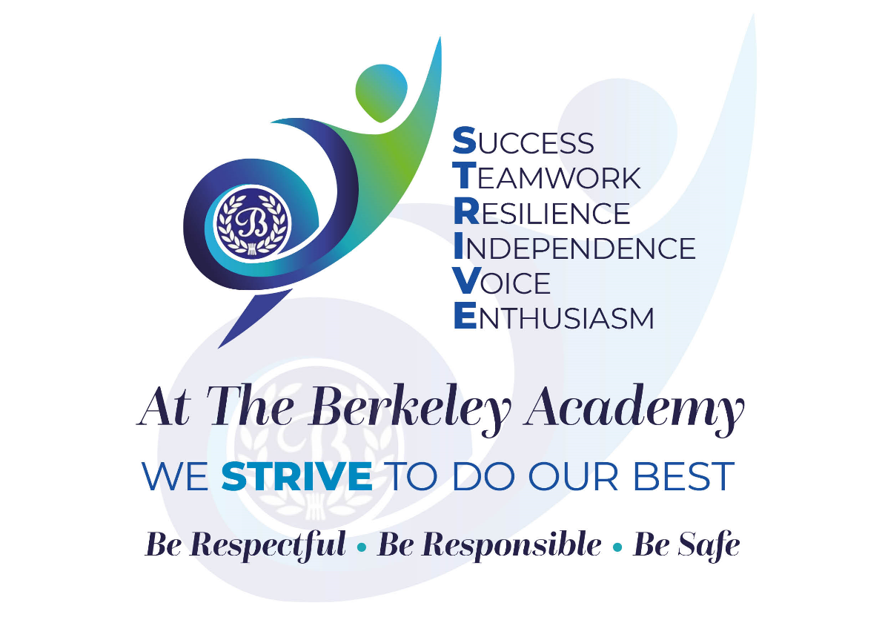

The Governing Board is completely aligned to the school’s vision and values.
At The Berkeley we provide a safe, nurturing environment where each child can achieve his/her full potential. We inspire a lifelong love of learning, in a warm, respectful and caring environment; learning through a rich, ambitious curriculum based on knowledge, understanding and enquiry. We promote a culture where pupils’ social, emotional and physical well-being is a priority, addressed through both curriculum and extra-curricular opportunities. Pupils are prepared for the next stages of life and understand the value of and are encouraged to see our school as the heart of the community.
The Governing Board has supported the introduction of a new set of values. These values are at the heart of everything in school and are known and can be articulated by all staff, pupils and governors. They are shared with visitors as they enter the school and are promoted visually within the school environment. By embracing the values in everything that we do, we are living out our vision.

Governing Body Impact

Over the 2023-24 academic year, we have:
- Appointed an experienced substantive headteacher.
- Monitored the impact of the school’s vision and values and gained greater understanding of how they underpin everything in school.
- Supported, monitored and challenged the progress of the focused objectives identified within the robust School Development Plan in order that school improvements with regard to provision for pupils are addressed and improved. These were broadly around standards, curriculum and behaviour and attitudes. Through visits to school and considering a variety of evidences, such as information presented at meetings and in link reports, governors were able to follow the developments and their impact.
- Appropriately challenged, held to account and monitored the Senior Leadership Team and their role in bringing about school improvements.
- Received regular updates about pupil and staff well-being and provision made within school.
- Tracked and posed questions about pupil attainment and progress and also that of identified pupil groups to ensure that termly progress towards end of year targets are met, and standards are high. Compared our headline data with national data.
- Monitored pupil attendance and considered the impact of new systems introduced.
- Carried out statutory roles regarding Safeguarding, SEND and Health and Safety, in order that the school remains compliant with regulations and provides the best opportunities for pupils in a safe environment. These link governors meet with lead teachers regularly and then report back to the full governing board.
- Worked strategically as link governors, meeting with the behaviour lead teachers to monitor the progress and impact of the close liaison with the Behaviour Hub, including the embedding and consistency of the new behaviour strategy in school. Governors have been well informed of changes through link governor reports and staff presentations.
- Worked closely with key staff members to ensure that the previously revised and refined curriculum was embedded. That it provided coherent, broad, balanced, ambitious opportunities for pupils and enriched pupils’ learning. Staff presented examples of work throughout the year to governors. In addition, at the end of the year, governors attended a showcase of pupil work and activities. Governors have built a closer working relationship with staff and as result feel well informed about developments and successes.
- Continued to monitor the outcomes from the new initiatives introduced in the previous year to improve standards eg. Little Wandle phonics scheme, Read to Write, Steps to Read. Regular link governor visits to school took place.
- Used the NGA Self-evaluation tool in order to prioritise developments required.
- Set a balanced budget for the year and monitored that funds are used appropriately to ensure that the school is well resourced in all aspects, meeting the needs of pupils and staff. ICT facilities have been upgraded; both for staff and pupils. Where efficiencies in staffing were required, this was addressed. Governors ensured that the school buildings were kept in good repair and developed as needed eg. replacing internal and external doors in line with H&S regulations, improvements to the outdoor environment, remedial work to drains, improving the administration area and signage and visual impact and communication in the entrance to school and the school hall. We benchmarked our spending against that of other schools (within the Local Authority and the Trust) to ensure that we were broadly in line with expectations and providing ‘value for money.’ Ensured appropriate allocation of staffing for the new academic year.
- As a result of checks made on procedures for planning and preparation for educational visits, children’s safety was ensured and statutory requirements met.
- Attended and engaged with relevant governor training so that skills are developed and awareness of important issues raised. This has included statutory training and beyond.
- Strengthened links with The Chancery Trust through engaging with the Chancery termly up-date document, attending termly meetings with representatives from other Chancery schools eg SEND governors, Chair of governors, Safeguarding governors, to share good practice and discuss topical and pertinent issues. Governors also attended the annual Chancery governors’ strategy day. Staff secondments between schools and a sharing of expertise and best practice has become a more common occurrence.

Future Aims and Intentions

In the coming year the Governing Board will:

- Continue to monitor the progress of the new School Development plan to ensure that school improvement strategies are effective.
- Continue to monitor and evaluate the Quality of Education to ensure that standards are high.
- Continue to have a presence in school regularly and to build professional working relationships with staff and pupils.
- Aim to foster stronger links with local businesses and the wider community.
- Monitor the provision and impact of extra-curricular activities.

Contextual challenges for the coming year:

- Manage the agreed short term dual role of Headteacher and CEO.
- Rising number of SEND pupils

How the Board thinks parents can support the school/trust to achieve their strategic aims:

- Attend school when opportunities and invitations are presented.
- Engaging with and responding to parent questionnaires and meetings. Your views are very important to us.
- Promote the school in the wider community.
- Reinforcing school aims and values at home.
- Reading regularly with your child and signing the home/school diary.
- Supporting FOBS (Friends of Berkeley School) to raise funds to support in those extra things that the budget doesn’t provide eg. coaches to the theatre at Christmas.
- Sharing your expertise and interests and any links/contacts you might have who would support the school either with sponsorship or by coming and sharing their knowledge and skills with pupils.

