


The Berkeley Academy

Governor Impact Statement 2024-2025

This Governing Board Impact Statement is produced annually and is a public document.

The statement includes:
- how we work as a Local Governing Board (LGB)
- how we align against the vision and values of the school
- how we work with the Headteacher, in line with the school improvement and development plan
- how we work within Chancery Multi Academy Trust
- our plans to sustain school improvement and impact.

Role of the Governing Board

The governors of the school have a range of duties and powers determined by Government legislation and the Scheme of Delegation of Chancery Multi Academy Trust. Working in partnership with the Headteacher, the governors meet on a half-termly basis to discuss key issues and make decisions. The Local Governing Board does not operate a committee structure but governors are encouraged to develop specialisms and work to their strengths.

We are committed to working together to ensure the children at The Berkeley Academy receive a full, balanced and enriched education.

We are responsible for setting the school’s vision and strategy; promoting high standards of educational achievement; managing the school budget; appointing and appraising staff; and monitoring progress on the School Development Plan.

Who are the Governing Board?

Members of the Local Governing Board are unpaid volunteers who have varied backgrounds and educational experiences. As at July 2025 our members are:

Governor | Type of Governor | Additional Responsibilities
Mrs Louise Gohr | Headteacher
Mrs Gill Barker | Co-opted | Chair Reading, Writing and Phonics link governor  Assessment
Mr Craig Dobson | Co-opted | Vice-Chair Behaviour link governor
Mrs Rachel Bridgett | Parent | Safeguarding
Mrs Tanya Houghton-Heath | Co-opted | SEND
Mr Gary McDougall | Parent | Health and Safety
Mrs Lynne Rowland | Co-opted | Pupil Premium and Looked After Children  RADY link governor
Mrs Heather Tynan | Staff | Staff well-being
Mrs Helen Sehne | Co-opted | Mathematics link governor Curriculum link governor
This year again, has seen the introduction of new governors which has enabled us to develop further and has broadened the range of skills and expertise we offer as a governing board. Roles and responsibilities have been adjusted accordingly throughout the year.

Further information on the Governing Board, including terms of office, declarations of business interest and governor attendance at meetings can be found on the school website.

If you are interested in finding out more about the role of a governor, or have any questions for the local governing board, please contact The Chair, Mrs Gill Barker via the school office.

Vision and Values

At The Berkeley Academy our vision is:

‘to equip all our children with the knowledge, understanding and enquiry skills to embrace lifelong learning, achieve their personal best and advance their social, emotional and physical well-being.’

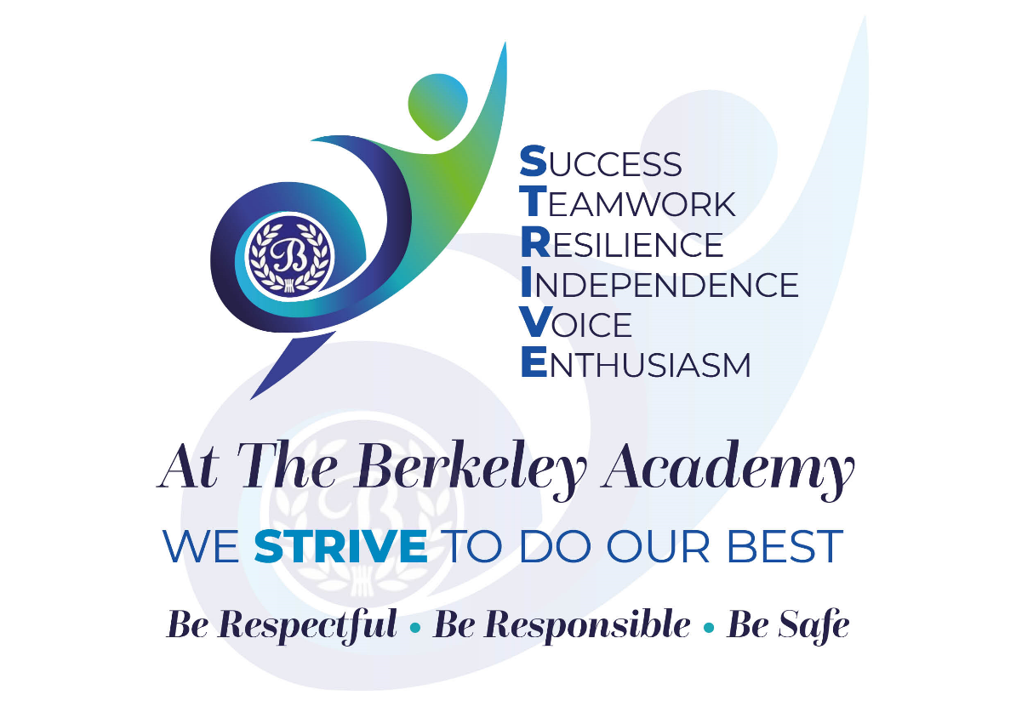

The Governing Board is completely aligned to the school’s vision and values.
At The Berkeley we provide a safe, nurturing environment where each child can achieve his/her full potential. We inspire a lifelong love of learning, in a warm, respectful and caring environment; learning through a rich, ambitious curriculum based on knowledge, understanding and enquiry. We promote a culture where pupils’ social, emotional and physical well-being is a priority, addressed through both curriculum and extra-curricular opportunities. Pupils are prepared for the next stages of life and understand the value of and are encouraged to see our school as the heart of the community.
The Governing Board has supported the introduction of a new set of values. These values are at the heart of everything in school and are known and can be articulated by all staff, pupils and governors. They are shared with visitors as they enter the school and are promoted visually within the school environment. By embracing the values in everything that we do, we are living out our vision.

Governing Body Impact

Over the 2024-25 academic year, we have:

- Been held to account twice this year by Ofsted. Questioning and scrutiny of minutes have confirmed that statutory duties are being met and upheld that the strategic work of the Board is efficient, providing appropriate support and challenge and that the Board contributes effectively to driving forward school improvement in all areas.
“Members of the board of trustees and of the governing body are forensic in their analysis of information. They are resolute in their efforts to ensure that pupils in the school are helped to flourish, both academically and socially. This extends to staff who are thoughtfully considered in terms of their workload being manageable. Staff said that they feel valued for the role that they play and are proud to be part of the school.”
The July pilot inspection has resulted in Governors being better prepared for the changes to inspection under a new framework, to be introduced in September 2025.
- Monitored the impact of the school’s vision and values and, through visits to school and meetings with staff and pupils, evidenced how they underpin everything in school.
- Supported, monitored and challenged the progress of the focused objectives identified within the robust School Development Plan in order that school improvements regarding provision for pupils are addressed and improved. These were broadly around the use of assessment to raise standards across the curriculum, ensuring equity in teaching for all pupils and improving engagement and involvement of our school and wider community. Through visits to school and considering a variety of evidence, such as information presented at meetings and in link reports, governors were able to track the developments and their impact.
- Appropriately challenged, held to account and monitored the Senior Leadership Team and Subject Leaders and their roles in bringing about school improvements.
- Received regular updates about pupil and staff well-being and provision made within school.
- Tracked and posed questions about pupil attainment and progress and that of identified pupil groups to ensure that termly progress towards end of year targets are met, and standards are high. Compared our headline data with national data.
- Monitored pupil attendance and considered the impact of school systems to address this.
- Carried out statutory roles regarding Safeguarding, SEND and Health and Safety, in order that the school remains compliant with regulations and provides the best opportunities for pupils in a safe environment. These link governors meet with lead teachers regularly and then report back to the full governing board. They also attend annual audits where appropriate.
- Arranged a meeting with our local MP. As a result, governors have raised the issues of SEND funding and provision (which is in crisis), at the highest level. Mr Naismith was made aware of the difficulties that school faces daily and how it is having an impact on meeting pupil needs both at The Berkeley and other schools in the area. We still await an up-date from the MP.
- Worked closely with key staff members to ensure that the previously revised and refined curriculum was embedded. That it provided coherent, broad, balanced, ambitious opportunities for pupils and enriched pupils’ learning. Staff presented examples of work throughout the year to governors. In addition, at the end of the year, governors attended a showcase of pupil work and activities. Governors have built a closer working relationship with staff and as result feel well informed about developments, plans for the future and successes.
- Used the NGA Self-evaluation tool to prioritise developments required.
- Set a balanced budget for the year and monitored that funds are used appropriately to ensure that the school is well resourced in all aspects, meeting the needs of pupils and staff. Staff laptops have been replaced. Governors ensured that the school buildings were kept in good repair and developed as needed eg. refurbished adult toilets in the main entrance; replaced carpet with hard floor covering in Year 1 classrooms and all corridors; adapted Reception class outdoor play equipment in line with health and safety considerations identified and installed new electric gates to the main staff car park, improving both safety and security. We benchmarked our spending against that of other schools (within the Local Authority and the Trust) to ensure that we were broadly in line with expectations and providing ‘value for money.’ Ensured appropriate allocation of staffing for the new academic year.
- As a result of checks made on procedures for planning and preparation for educational visits, children’s safety was ensured and statutory requirements met. Governors attended a range of day and residential visits.
- Attended and engaged with relevant governor training so that skills are developed and awareness of important issues raised. This included statutory training and beyond. This year mental health support was prioritised.
- The Board is better informed about mental health provision in school and through checks made by the Safeguarding governor, the Board is satisfied that provision for pupils is the best that it can be and meets guidelines.
- Strengthened links with The Chancery Trust through engaging with the Chancery termly up-date document, attending termly meetings with representatives from other Chancery schools eg SEND governors, Chair of governors, Safeguarding governors, to share good practice and discuss topical and pertinent issues. Governors also attended the annual Chancery governors’ strategy meeting. A sharing of expertise and best practice between schools in the Trust has continued.

Future Aims and Intentions

In the coming year, in addition to carrying out statutory duties, the Governing Board will:

- Continue to monitor the progress of the new School Development plan to ensure that school improvement strategies are effective.
- Continue to monitor and evaluate the Quality of Education to ensure that standards are high.
- Monitor the re-evaluation and refinement of the school curriculum to ensure that it is progressive, ambitious, broad and exciting and that pupils can build on key knowledge year by year, knowing more and remembering more.
- Ensure that that the two key action points identified by Ofsted are addressed.
- Continue to have a presence in school regularly and to build professional working relationships with staff and pupils.
- Strengthen links with the wider community.

Contextual challenges for the coming year:

- Manage the continuing dual role of Headteacher and CEO.
- Rising number of SEND pupils and relevant funding.

How the Board thinks parents can support the school/trust to achieve their strategic aims:

- Attend school when opportunities and invitations are presented.
- Engaging with and responding to parent questionnaires and meetings. Your views are very important to us.
- Promote the school in the wider community.
- Reinforcing school aims and values at home.
- Reading regularly with your child and signing the home/school diary.
- Supporting FOBS (Friends of Berkeley School) to raise funds to support in those extra things that the budget doesn’t provide eg. coaches to the theatre at Christmas.
- Sharing your expertise and interests and any links/contacts you might have who would support the school either with sponsorship or by coming and sharing their knowledge and skills with pupils.

