

The Berkeley Academy Nursery
Laidon Avenue
Crewe
CW2 6RU

ARE YOU LOOKING FOR A NURSERY PLACE FOR YOUR CHILD FOR
JANUARY 2027 or
SEPTEMBER 2027?
At the Berkeley Academy nursery, we offer paid and funded places for children from 2 to 4 years old.
We would like to invite you to come and have a look around our nursery on one of the following dates:
Tuesday 22nd September 2026 – 9.30am
Friday 16th October 2026 – 1pm
Wednesday 18th November 2026 – 9.30am
To book a place, or for more information, please telephone the school office on 01270 845726 or email: admin@berkeley.cheshire.sch.uk
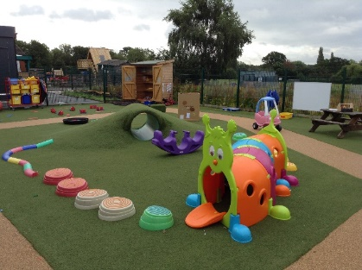
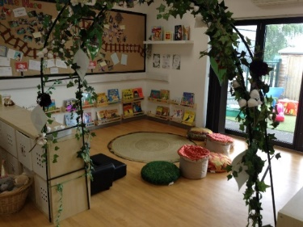
We look forward to meeting you!



