

The Berkeley Academy

Governor Impact Statement 2025-2026

This Governing Board Impact Statement is produced annually and is a public document.

The statement includes:
- how we work as a Local Governing Board (LGB)
- how we align against the vision and values of the school
- how we work with the Headteacher, in line with the school improvement and development plan
- how we work within Chancery Multi Academy Trust
- our plans to sustain school improvement and impact.

Role of the Governing Board
The governors of the school have a range of duties and powers determined by Government legislation and the Scheme of Delegation of Chancery Multi Academy Trust. Working in partnership with the Headteacher, the governors meet on a half-termly basis to discuss key issues and make decisions. The Local Governing Board does not operate a committee structure but governors are encouraged to develop specialisms and work to their strengths.

We are committed to working together to ensure the children at our The Berkeley Academy receive a full, balanced and enriched education.

We are responsible for setting the school’s vision and strategy; promoting high standards of educational achievement; managing the school budget; appointing and appraising staff; and monitoring progress on the School Development Plan

Who are the Governing Board?
Members of the Local Governing Board are unpaid volunteers who have varied backgrounds and educational experiences. As of July 2026, our members are:
Name | Type | Additional responsibilities
Mrs Louise Gohr | Headteacher
Mrs Gill Barker | Co-opted | Chair of Governors  Headteacher well-being  Headteacher Performance Management Panel  School Development Plan (SDP) priority 1 Curriculum  SDP priority 2 Assessment and Standards
Mrs Rachel Bridgett | Parent | Vice Chair of Governors  Link governor for Safeguarding  SDP priority1 Curriculum  Teacher Pay Panel
Mrs Tanya Houghton-Heath | Co-opted | Link governor for SEND  SDP Priority 3 Zones of Regulation  SDP priority 2 Assessment and Standards
Mrs Amanda Mellor | Chancery Trustee
Mr Gary McDougall | Parent | Link governor for Health and Safety  SDP priority 2 Assessment and Standards  Teacher Pay Panel
Mrs Lynne Rowland | Co-opted | Pupil Premium and Looked After Children  RADY link governor  SDP Priority 3 Zones of Regulation  Teacher Pay Panel
Mrs Helen Sehne | Staff | Link governor for Staff and Pupil Well-being

The following members stepped down in the year, and we would like to thank them for their contributions:

- Mr Craig Dobson, Vice Chair of Governors, Link governor for Behaviour and Attendance
- Ms Natalie Waters, Sustainability and Climate link governor

Two new governors have been recruited to join the Board for 2026-27.

Further information on the Governing Board, including terms of office, declarations of business interest and governor attendance at meetings can be found on the school website.

If you are interested in finding out more about the role of a governor, or have any questions for the local governing board, please contact the Chair of Governors, Mrs Gill Barker, via the school office.

Vision and Values

At The Berkeley Academy our vision is:

‘To equip all our children with the knowledge, understanding and enquiry skills to embrace lifelong learning, achieve their personal best and advance their social, emotional and physical well-being.’
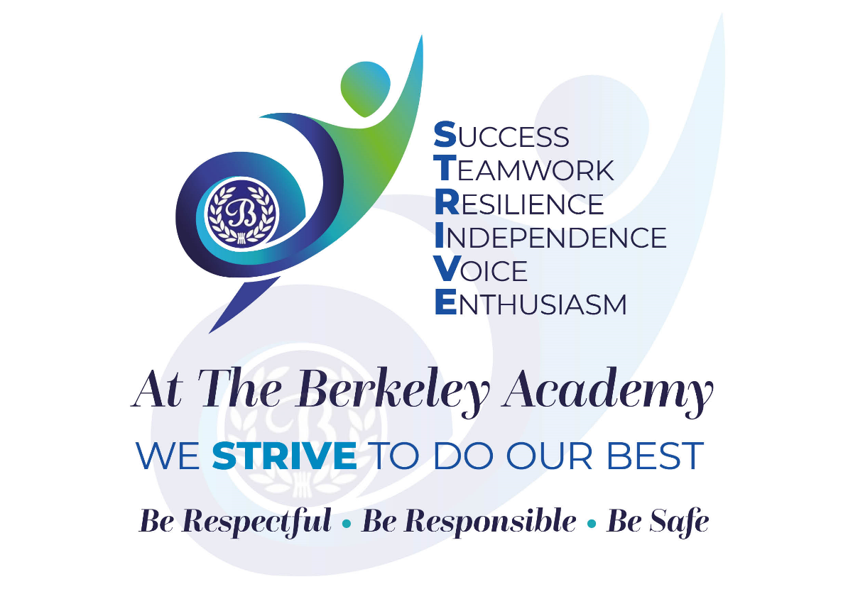

The Governing Board is completely aligned to the school’s vision and values.

At The Berkeley Academy we provide a safe, nurturing environment where each child can achieve his/her full potential. We inspire a lifelong love of learning, in a warm, respectful and caring environment; learning through a rich, ambitious curriculum based on knowledge, understanding and enquiry. We promote a culture where pupils’ social, emotional and physical well-being is a priority, addressed through both curriculum and extra-curricular opportunities. Pupils are prepared for the next stages of life and understand the value of and are encouraged to see our school as the heart of the community.
The Governing Board strongly supports the school’s values. These values are at the heart of everything in school and are known and can be articulated by all staff, pupils and governors. They are shared with visitors as they enter the school and are promoted visually within the school environment. By embracing the values in everything that we do, we are living out our vision.

Governing Body Strengths
Over the 2025-26 academic year…

- The Local Governing Body has continued to provide effective strategic leadership, support and challenge to ensure the school remains focused on its vision of enabling all pupils to flourish academically, socially and emotionally. Through discussions with pupils, staff and parents, alongside regular visits to school, governors have monitored how the school's vision and values are embedded in everyday practice and evidenced that they underpin decision-making, curriculum development and the wider life of the school.

- The Board has maintained a strong focus on the strategic priorities identified within the School Development Plan. Governors have supported, monitored and challenged leaders to ensure effective progress in key areas. These include the refinement and implementation of our ambitious curriculum, promoting sustained learning and long-term retention; refining evidence-informed assessment strategies that support adaptive teaching and raise academic standards for all learners; enhancing pupil’s emotional literacy, self-regulation and independence through the implementations of the Zones of Regulations framework. Through governor visits, link governor reports, presentations from school leaders and analysis of school information, governors have been able to track developments and evaluate the impact of improvement strategies and their contribution to better outcomes for pupils.

- The link governor for sustainability has monitored the Sustainability Strategy to ensure that it is well embedded. There is evidence of strong staff and pupil-led initiatives that were successful in raising awareness and reducing waste across the school.

- Throughout the year, governors have robustly held school leaders to account for the quality of education and pupil outcomes. Governor monitoring of the development and impact of the new leadership structure confirmed improved efficiencies through the distribution of monitoring tasks and day-to-day operations. Termly tracking and questioning of attainment, progress and performance data, including analysis of specific pupil groups, enabled governors to challenge leaders and monitor progress towards ambitious end-of-year targets. Governors compared school performance against national benchmarks and maintained oversight of pupil attendance, evaluating the effectiveness of strategies implemented to improve attendance and engagement.

- Governors have also closely monitored the wellbeing of pupils and staff, receiving regular updates on pastoral provision, welfare and support systems. This has been particularly relevant this year in light of the death of a pupil. Attention has been given to mental health provision, and bereavement support where appropriate. Governors ensure that support more generally meets statutory expectations and effectively responds to the needs of the school community.

- The Board has fulfilled its statutory responsibilities through dedicated link governor roles for safeguarding, SEND, health and safety and other key areas. Link governors have met regularly with school leaders, undertaken monitoring activities, participated in audits and reported findings to the full governing body. This systematic approach has ensured continued compliance with statutory requirements and helped maintain a safe, supportive and inclusive environment for all pupils.

- A significant area of focus has been the refinement and implementation of the curriculum. Governors worked closely with leaders and staff to ensure that the curriculum remains coherent, broad, balanced and ambitious. Through curriculum presentations, scrutiny of pupils' work, classroom visits and attendance at curriculum showcases, governors gained first-hand evidence of pupils' learning experiences and the positive impact of curriculum developments. It has been clear that the new curriculum design is clear, well-sequenced and well-resourced which has enabled pupils to retain knowledge effectively. The new approach and resources have reduced staff workload, a key consideration for governors in promoting wellbeing. These activities have strengthened governors' understanding of educational provision and fostered strong professional relationships with staff.

- The Governing Board has continually sought to improve its own effectiveness. Governors used the Ofsted toolkit to carry out a comprehensive self-evaluation of its effectiveness. In producing and refining a self-evaluation document, governors ensured that the LGB was effective in having a positive impact on the development of all aspects of school provision.

- The focus for training this year has been on Inclusion, preparing governors for the new expectations. Link governors have taken the opportunity to attend parent workshops such as, Cheshire East Police online-safety.

- Financial oversight has remained a key priority. Governors approved and monitored a balanced budget, ensuring that resources were allocated effectively and represented value for money. Through rigorous financial monitoring and benchmarking against both Trust and local authority schools, governors ensured that expenditure remained appropriate whilst supporting school improvement priorities.

- Investment during the year included improvements to school facilities such as reconfiguring of a double mobile classroom to accommodate year 1 pupils and repairing the year 6 block roof. Toilets have been modified to be age appropriate for Year 2. Window blinds have been replaced, where required, throughout school. As per the sustainability plan, a bike shelter has been installed. A special place to remember Rosie has been created in the form of a memorial garden incorporating all the things that she loved. Other works have been completed as per the Premises Plan rolling program. Overall upgrades to learning environments and enhanced site security through the installation of a password sensitive keypad at the front door have been actioned. Governors also ensured that staffing structures for the coming academic year were appropriately resourced to meet pupils' needs.

- The Board monitored educational visit procedures to ensure that statutory requirements were met and that pupils could safely participate in a wide range of enrichment opportunities. Governors have sought assurance that health and safety procedures were robust and that pupils benefited from valuable learning experiences beyond the classroom, linked to the curriculum.

- Finally, governors strengthened collaboration across The Chancery Trust through attendance at strategy meetings, governor network forums and termly updates. Engagement with colleagues across the Trust has enabled the sharing of expertise, effective practice and emerging developments, further enhancing governance effectiveness and supporting continuous school improvement. The governors are aware of the close alignment between the Chancery Development Plan and The Berkeley School Development Plan. The sharing of The Berkeley LGB self-evaluation process with other Chancery ‘Chairs’ supported trust-wide development and promoted collaborative work across schools.

As a result of rigorous monitoring, strategic challenge, informed support and ongoing professional development, the Local Governing Body is confident that significant progress has been made towards the school's strategic aims. Governors remain committed to ensuring that the school continues to provide a high-quality education, strong pastoral support and enriching opportunities that enable all pupils to thrive and succeed.

Future Priorities and Next Steps

In the coming year, in addition to carrying out our statutory duties, the Governing Board will:

- Monitor the progress of the new School Development plan to ensure that school improvement strategies are effective. The broad areas of the SDP
- Continue to monitor and evaluate the Curriculum and Teaching to ensure that standards remain high.
- Monitor the implementation and impact of the revised RHE curriculum.
- Ensure that that the two key action points identified by Ofsted are addressed.
- Develop governor skills, building confidence and shared ownership across the board.
- Continue to have a presence in school regularly and to build professional working relationships with staff and pupils.
- Strengthen links with the wider community.

Contextual challenges for the coming year include:

- During 2026-2027, the Governing Board will continue to support and monitor the effective leadership of the school while managing the ongoing dual role of Headteacher and Chief Executive Officer. Governors will work closely with senior leaders and Trust colleagues to ensure that leadership responsibilities remain manageable.

- The rising number of pupils with Special Educational Needs and Disabilities (SEND) remains a significant challenge for the school. Whilst the school remains committed to providing high-quality provision and ensuring that every child receives the support they need to succeed, the continued gap between available funding and the level of need presents an ongoing challenge. Governors will continue to monitor SEND provision, advocate for appropriate funding and ensure that available resources are deployed as effectively as possible to meet pupils' needs.

- A further priority for the coming year will be the continuation of preparations to introduce the new Inclusion Strategy. Governors recognise the importance of ensuring that all pupils, regardless of need, background or starting point, can access a broad, ambitious and inclusive education. The successful implementation of this work will be vital in promoting equity, reducing barriers to learning and ensuring that all pupils are able to thrive.

- The school must also be prepared for the potential impact on pupil numbers due to local housing developments and the establishment of new primary schools within the area. Governors will work alongside school and Trust leaders to monitor local developments carefully, assess any implications for the school's long-term sustainability and ensure that the school remains an attractive and high-performing choice for families within the community.

- Currently Nursery enrolment is forecast to fall. This will need to be monitored closely and responded to as it could impact on school numbers in the future.

- Governors remain mindful of the wider financial pressures facing schools nationally. The continuation of careful financial planning, prudent use of resources and ongoing evaluation of spending priorities will be required to ensure that the school continues to deliver high-quality provision whilst maintaining financial stability.

Parents/carers can support the school and board to achieve its strategic aims by:

- Parents and carers can play a vital role in supporting the school's vision, values and improvement priorities by actively engaging with the opportunities provided by the school. Attendance at parent consultations, curriculum events, performances, workshops, assemblies and other school activities helps to strengthen relationships between families and staff, whilst demonstrating to children the value placed on their education and personal development.

- Parents and carers are encouraged to participate in questionnaires, surveys, consultations and meetings throughout the year. The Governing Board and school leaders value the views of families and recognise the important contribution that parent feedback makes in shaping future developments.

- Families can also support the school by acting as positive ambassadors within the wider community. Promoting the school's achievements, values and successes helps to strengthen its reputation and supports the continued growth of a strong and vibrant school community.

- Parents and carers play a key role in reinforcing the school's aims and values at home. By encouraging respect, resilience, responsibility, kindness and a positive attitude towards learning, families help children develop the personal qualities that underpin both academic achievement and personal success. Consistency between home and school supports pupils in becoming confident, responsible and successful learners.

- Parents and carers should ensure that children attend school punctually on a daily basis, refreshed and ready to learn, unless illness prevents this, in which case the school should be informed.

- Regular reading at home remains one of the most effective ways that parents can support their child's education. Listening to children read, discussing books together and signing the home-school diary helps to build strong literacy skills, develop a love of reading and strengthen communication between home and school.

- The Governing Board also encourages parents and carers to support Friends of Berkeley School (FOBS). Through fundraising events and community activities, FOBS makes an invaluable contribution to enhancing the educational experiences available to pupils. Funds raised often provide opportunities and resources that fall beyond the school's budget, such as educational visits, theatre experiences, enrichment activities and additional equipment that benefit all children.

- Finally, parents and carers can make a valuable contribution by sharing their skills, expertise, professional knowledge and community links with the school. Whether through sponsorship opportunities, volunteering, delivering talks, supporting projects or introducing contacts who may enrich pupils' learning experiences, these contributions help broaden children's horizons and strengthen the school's connections with the wider community.

By working together in partnership, parents, carers, staff and governors can ensure that the school continues to achieve its strategic aims, providing the highest quality education, care and opportunities for every child.

