

Welcome to your new class!

Class 10

Your new teachers are Miss Slater and Mr Harrison. We can’t wait to spend a fantastic year with you all!

Miss Slater will teach you Tuesday-Friday each week.

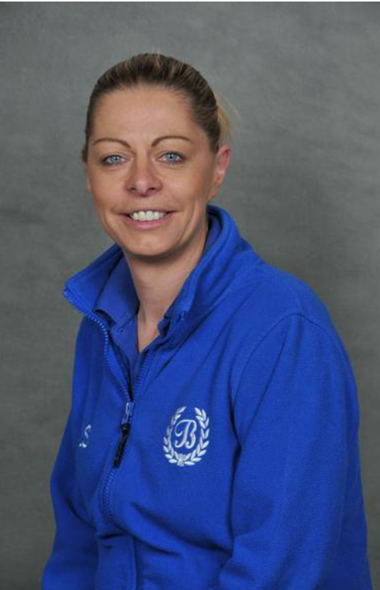

We spent two days for transition in your new classroom. By September, we will have decorated it with your beautiful artwork.

The toilets in Year 4 are down by the main playground.

In Year 4, you will have your own locker in the corridor to put your belongings in.

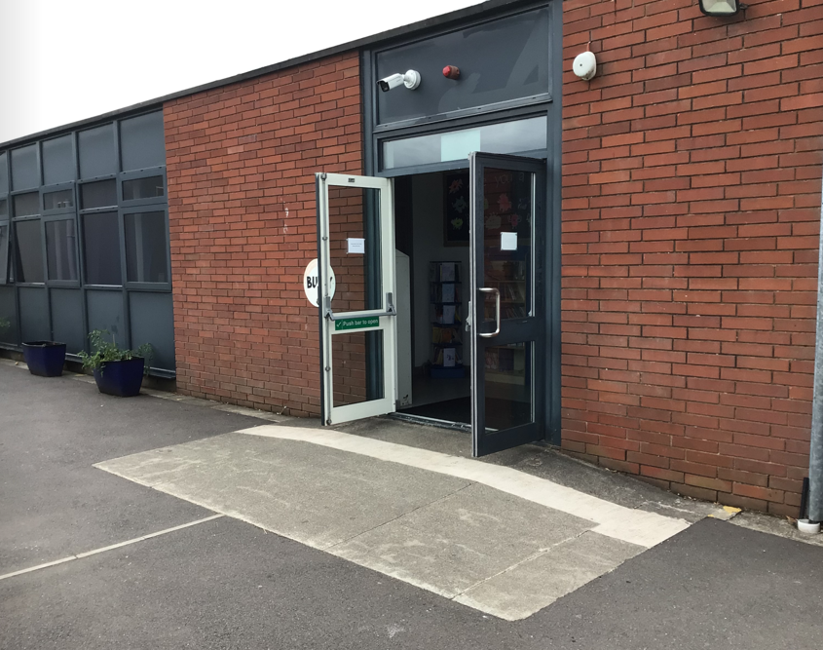
This is where you will come into school. This is opposite the school field.
Doors will open at 8:45 AM. We will finish the day at 3:20 PM. Your parents or carers will pick you up from these doors too.
Our new curriculum
In Year 4 we will be learning a range of new and exciting things.
In the Autumn term we will be learning about numbers to 10,000, puffins and Ancient Greece!

This is the playground.

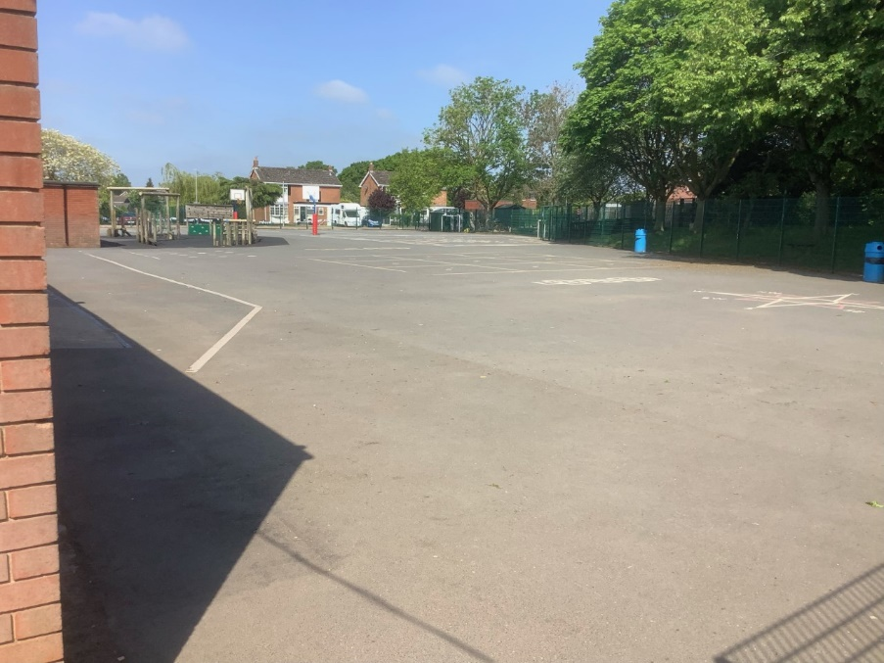
We have playtimes on here and we use it when we do P.E. outside. We use the field when it is dry.
Our playtime is at 10:50 AM until 11:05 AM.
Our lunchtime is 12:15 PM until 1:10 PM.

We hope that you are excited about starting your new class at The Berkeley.

You can look on our website for more information about the school.

We look forward to seeing you!

