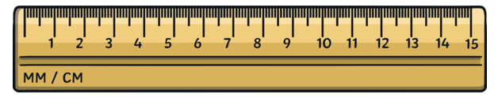

There are many different sized objects around your house. Cut out the ruler above and have a go at measuring different objects around the house with the ruler, to see how big they are. Maybe you could even find things that are bigger or smaller than other things! Record your findings with a grown up in the table below:

Object | Size (CM) | Is it Big or Small? Tick the box  Big Small

We would love to see what you have been up to on tapestry!

